14 December 2011

Debt Collection Consultation
Consumer Affairs Victoria
Policy and Legislation Branch
GPO Box 123
Melbourne VIC 3001

By email: debt.collection@justice.vic.gov.au

Dear Sir/Madam

Re: Debt Collection Harmonisation Regulation Options Paper (October 2011)

Thank you for the opportunity to comment on Consumer Affairs Victoria (CAV)’s Debt Collection Harmonisation Regulation Options Paper (the Options Paper).

As an industry-based external dispute resolution scheme, the Energy and Water Ombudsman (Victoria) (EWOV) provides alternative dispute resolution services to Victorian energy and water customers by receiving, investigating and resolving complaints. In making this submission, EWOV bases its comments on our extensive case handling experience, including complaints about affordability, credit and debt collection issues.

EWOV provides comments on the following options for harmonisation:

- Licensing
- Conduct
- Complaint handling
- Information standards.

Licensing options

EWOV has jurisdiction to investigate debt collection issues resulting from outstanding energy and water accounts. Over the years, we have noted a significant increase in customers being concerned about debt collection, including the application of a credit rating or the involvement of a debt collection agency:

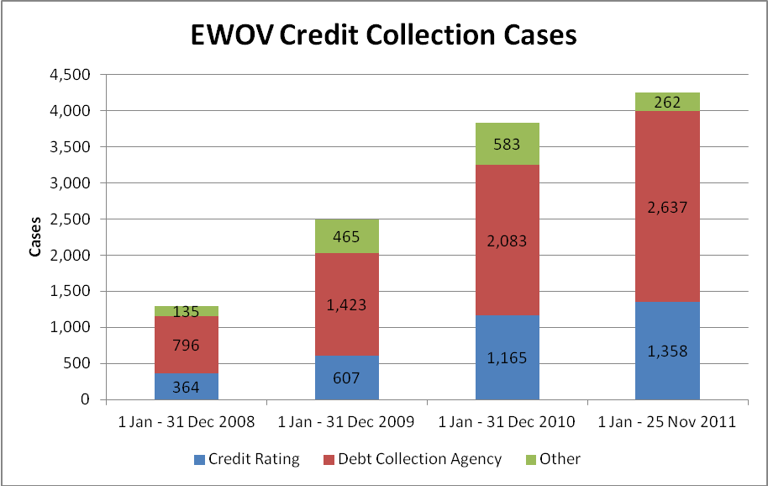

As consumers experience rising price pressures, EWOV foresees a continuing increase in credit collection cases. We have also noted a growing number of debt collectors in Victoria. To strengthen consumer confidence and to provide for a greater degree of industry consistency during the growth and change of its landscape, EWOV supports CAV’s option to remove the exemption for third-party collectors from the National Credit Act. In applying these requirements in the context of consumer credit, new collectors will be encouraged to comply with prescribed licensing obligations. Such compliance can then also be consistently audited.

Conduct options

Although mandatory codes may appear prescriptive, it is EWOV’s experience that they provide for greater consumer certainty and serve as a reliable compliance measure. An example from within the Victorian energy sector is the Marketing Code of Conduct (the Code) administered by the Essential Services Commission. The Code outlines requirements for salespeople, including allowable marketing hours and acceptable conduct. It serves as a reference point for all industry participants, including salespeople, energy retailers engaging them and the Ombudsman office investigating consumers’ marketing and transfer complaints. As such the Code provides for consistency and facilitates parties’ understanding of their rights and obligations.

Within the area of debt collection, EWOV suggests considering the Australian Competition & Consumer Commission and Australian Securities & Investments Commission’s Debt Collection Guideline (the Guideline). As this Guideline has been established industry-wide and sets out important conduct provisions, it may serve as an effective tool for national adoption within the context of a regulatory framework.

As both the Code and the Guideline have proven to be efficient and effective, EWOV supports the introduction of a mandatory code of conduct for debt collectors.

Complaint handling options

As an external dispute resolution (EDR) scheme, EWOV primarily investigates and resolves complaints. We however also focus on building customer capability, informing them about their rights and responsibilities. Additionally, we provide scheme participant training to equip provider staff with efficient and effective internal dispute resolution (IDR) tools.

Mandatory IDR processes

Having an appropriate and effective IDR process in place will provide guidance and ensures consistency in case handling procedures. A robust IDR model will further decrease the need to engage external services and avoid associated EDR costs. In our experience, customers rarely exploit mandatory EDR schemes but see them as an independent and impartial alternative assessing their concerns. EWOV for example requires the parties to a dispute to attempt the resolution of their concerns directly with each other before taking the matter to the scheme. This initial direct contact requirement further reduces any exploitation concerns by industry.

For the above reasons, EWOV supports the establishment of mandatory IDR processes.
Mandatory membership of an EDR scheme

Given EWOV’s extensive experience in the provision of EDR services in the Victorian utilities sector, we strongly support the continuation of existing EDR schemes handling debt collection disputes about matters within jurisdiction and expertise. In EWOV’s case, debt collection matters brought before the scheme are resolved through the energy or water company with which the debt was generated, as debt collectors operate as agents or contractors.

As noted by CAV in the Options Paper, debt collection matters are already taken up by relevant EDR schemes, such as the Telecommunications Industry Ombudsman and state energy and water Ombudsmen. EWOV suggests not duplicating these jurisdictions to avoid consumer confusion. EWOV already refers consumers to other bodies that are experts in the area of consumer-specific disputes. In our experience such a referral process works well between schemes. EWOV therefore recommends maintaining the jurisdiction of current EDR schemes and making use of their expertise.

Information standards options

To facilitate consumers’ understanding of outsourced debts and the parties involved, EWOV supports the option to prescribe statutory forms. It should not be up to the consumer to request information about who is pursuing their outstanding account and what the requested monetary amount is related to.

It would further be beneficial to consumers to include contact information of appropriate EDR schemes. Energy and water retailers in Victoria for example have to advise their customers of EWOV’s contact details on a regular basis, including all energy disconnection and water restriction warnings.

Providing minimum information will further facilitate the discussion between the parties about payment obligations.

We trust the above comments are helpful. If you require further information or have any queries, please contact Tanja Sommer, Senior Research and Communications Officer on 03 8672 4460.

Yours sincerely

Fiona McLeod
Energy and Water Ombudsman (Victoria)

It is important to note that even though providers can on-sell debt to third-party collectors, it is within EWOV’s jurisdiction to investigate such outstanding accounts.
For more information on the Code please refer to the Victorian Essential Services Commission’s website www.esc.vic.gov.au
Please note that EWOV involves the energy companies in its marketing/transfer cases as they are responsible for their agents’ conduct.

