CONSUMER AFFAIRS VICTORIA
SECTION 218 of the AUSTRALIAN CONSUMER LAW (VICTORIA)
ENFORCEABLE UNDERTAKING
The commitments in this Undertaking are offered to the Director of Consumer Affairs Victoria by:
ZAPATIN IMPORTS PTY LTD
(ACN 137 282 663)
of 82 Keys Road, Cheltenham Victoria 3192
– and –
NUO XING
– and –
YIN WEI
The Director
- The office of the Director of Consumer Affairs Victoria (“the Director”) is provided for under section 107 of the Australian Consumer Law and Fair Trading Act 2012 (Vic) (“the Act”). The holder of that office is responsible for the administration of the Act, the Australian Consumer Law (“the ACL”) which has been enacted as a law of Victoria under Part 2-2 of the Act and known as the Australian Consumer Law (Victoria) (“the ACL (Vic)”), together with Victoria’s other consumer protection legislation.
- The Director, as a Regulator for the purposes of the ACL (Vic), may accept a written Undertaking from any person in connection with any matter in relation to a contravention of the ACL (Vic) in respect of which the Director has a power or function, as a means of resolving contraventions of the ACL (Vic).
Zapatin Imports Pty Ltd
- Zapatin Imports Pty Ltd (ACN 137 282 663) (“the company”) is an Australian proprietary company limited by shares, which was registered on 25 May 2009. At all relevant times, the company had and has its registered office and principal place of business at 82 Keys Road, Cheltenham Victoria 3192.
- The company carries on business, in trade or commerce, as an importer, wholesaler of homewares, crafts, furniture and children’s toys.
- Ms Nuo Xing is and was, at all times relevant to this Undertaking:
- the sole director and shareholder of the company; and
- a person responsible ultimately for acquiring, or arranging the acquisition of, goods supplied or offered for sale to the public by the company.
- Mr Yin Wei is and was, at times relevant to this Undertaking, a person responsible for acquiring, or arranging the acquisition of, goods supplied or offered for sale to the public by the company.
Legislation
- On 1 January 2011, the ACL, set out in Schedule 2 to the Competition and Consumer Act 2010 (C’th), came into effect. Part 2.2 of the Act applies the ACL as a law of Victoria, which is known as the ACL (Vic). Part 3-3 of the ACL (Vic) deals with the safety of consumer goods and product-related services.
- Section 104 of the ACL (Vic) provides for the imposition, by the Commonwealth Minister for Competition Policy and Consumer Affairs (“the Commonwealth Minister”), of a mandatory safety standard for consumer goods of a particular kind to prevent or reduce risk of injury to any person.
- Section 106 of the ACL (Vic) imposes an obligation upon persons to refrain from:
- in trade or commerce, supplying or offering for supply consumer goods; or
- possessing or have control of consumer goods, in or for the purposes of trade or commerce –
if a safety standard is in force in respect of those goods.
- Section 194 of the ACL (Vic) creates an offence which is committed if a person:
- in trade or commerce, supplies or offers for supply; or
- possesses or has control of, in or for the purposes of trade or commerce –
consumer goods of a particular kind if a safety standard is in force in respect of those goods.
- Section 114 of the ACL provides for the imposition, by the responsible Commonwealth Minister of permanent ban orders for consumer goods of a particular kind to prevent or reduce the risk of injury to any person.
- Section 118 of the ACL (Vic) imposes an obligation upon persons to refrain from:
- in trade or commerce, supplying or offering for supply consumer goods; or
- possessing or having control of consumer goods, in or for the purposes of trade or commerce –
if a permanent ban order is in force in respect of those goods.
- Section 197 of the ACL (Vic) creates an offence which is committed if a person:
- in trade or commerce, supplies or offers for supply; or
- possesses or has control of, in or for the purposes of trade or commerce –
consumer goods of a particular kind if an interim or permanent ban order is in force in respect of those goods.
Mandatory Safety Standards
- For the purposes of Part 3-3 of the ACL, pursuant to section 65E of the Trade Practices Act 1974 (C’th), and for the purposes of section 65C of that Act, the Commonwealth Minister made a mandatory safety standard, on 17 December 2003, relating to toys for children up to and including 36 months of age by way of Consumer Protection Notice No. 14 of 2003 – Consumer Product Safety Standard: Toys for Children up to and including 36 months of age, published on the internet (“the children’s toys standard”), which is a mandatory standard by the operation of clause 4 to Schedule 7 of the Trade Practices Amendment (Australian Consumer Law) Act (No. 2) 2010, and which continues in effect as if imposed pursuant to subsection 104(1)(a) of the ACL (Vic).
- The children’s toys standard prohibits the supply of toys manufactured and designed, marketed or labelled for children under 36 months of age, which fail to meet the requirements of the children’s toys standard.
- A copy of the children’s toys standard is available and may be downloaded from the website at www.productsafety.gov.au.
Permanent Ban Order
- For the purposes of Part 3-3 of the ACL, the Commonwealth Minister imposed a permanent ban order, on 1 February 2011, pursuant to sub-section 114(1)(a) of the ACL, by way of Consumer Protection Notice No. 20 of 2011, and caused details of the permanent ban order to be published on the internet and which, by the operation of clause 4 to Schedule 7 of the Trade Practices Amendment (Australian Consumer Law) Act (No. 2) 2010, continues in effect as if imposed pursuant to sub-section 114(1)(a) of the ACL.
- The permanent ban order prohibits the supply of goods known as “Yo-Yo Water Balls” and similar products. These are toys intended to be thrown and returned to the hand, consisting of an elastic cord extendable to at least 500 mm in length, usually with a loop at one end to wear around the finger, and a soft synthetic object on the other. The object may be filled with liquid or air, and/or contain a novelty (“the Yo-Yo Water Ball ban order”). This ban excludes outdoor and sporting toys, such as a practice tennis ball retained on an elastic tension cord intended to be anchored, a bat with a ball attached by an elastic cord and goods known as the “Yo-Be Sling Disc”.
- A copy of the permanent ban order on Yo-Yo Water Balls is available and may be downloaded from the website www.productsafety.gov.au.
Consumer Affairs Victoria Investigation
- On or about 14 November 2012, Consumer Affairs Victoria Inspectors conducted a routine compliance monitoring inspection at the company’s business premises at 82 Keys Road, Cheltenham Victoria 3192, where they located and seized:
- 917 caterpillar Yo-Yo Water Balls;
- 321 small Yo-Yo Water Balls;
- 315 man Yo-Yo Water Balls;
- 137 pull down clown wooden toys;
- 40 “Beating Ball Table” wooden toys; and
- 8 mini helicopter wooden toys –
(“the goods”) –
depicted and described in Annexure “A” below, on suspicion that the goods were subject to the children’s toy standard or the Yo-Yo Water Ball ban order and that the company was prohibited from supplying, or offering to supply, those goods.
- Tests conducted on samples of the goods, seized by Consumer Affairs Victoria Inspectors, confirmed that:
- each of the Yo-Yo Water Balls, referred to in paragraph 20(a) to (c) above, failed the requirements of the Yo-Yo Water Ball ban order in that the elastic cord attached to the synthetic object is capable of stretching in excess of 500 mm;
- the pull down clown wooden toys, identified in paragraph 20(d) above, failed the requirements of clause 4.1 of the children’s toy standard in that, when tested in accordance with the testing regime provided for in clause 5.24.6.1 of the children’s toy standard, the toy was found to liberate a small part which fitted entirely, whatever its orientation, within the small parts cylinder depicted and defined in paragraph 5.2 (Figure 13) of the children’s toy standard; and
- the “Beating Ball Table” wooden toys, identified in paragraph 20(e) above, failed the requirements of clause 4.1 of the children’s toy standard in that, when tested in accordance with the testing regime provided for in clause 4.4.1 of the children’s toy standard, the toy was found to contain small parts which fitted entirely, whatever their orientation, within the small parts cylinder depicted and defined in paragraph 5.2 (Figure 13) of the children’s toy standard; and
- the mini helicopter wooden toys, identified in paragraph 20(f) above, failed the requirements of clause 4.1 of the children’s toy standard in that, when tested in accordance with the testing regime provided for in clause 5.24.6.1 of the children’s toy standard, the toy was found to liberate a small part which fitted entirely, whatever its orientation, within the small parts cylinder depicted and defined in paragraph 5.2 (Figure 13) of the children’s toy standard.
- Mr Yin Wei, on behalf of the company, has subsequently confirmed that the goods, of the same type as those identified in Annexure “A” below, were acquired by the business as trading stock for sale in November 2008 and purchased the goods from a supplier in China.
Contraventions of the ACL
- A person who contravenes sections 194 or 197 of the ACL is liable, on conviction, to a fine, in respect of each offence, of not more than:
- $220,000 in the case of an individual; or
- $1.1 million in the case of a body corporate.
- Alternatively, a person who contravenes sections 106 or 118 of the ACL may, in civil proceedings brought for contraventions of that section, be subject to the range of remedies available under Part 5-2 of the ACL, including pecuniary penalties in respect of each contravention of not more than:
- $220,000 in the case of an individual; or
- $1.1 million in the case of a body corporate.
Acknowledgment of the Breach
- Each of Ms Nuo Xing and Mr Yin Wei, on behalf of the company, acknowledges that on various occasions during the period November 2008 to 14 November 2012 (“the period”), the company contravened sections 108 and 118 of the ACL, in or for the purpose of trade or commerce, by:
- offering to supply;
- supplying; and
- possession or having under its control –
the goods which contravened either the children’s toy standard or the Yo-Yo Water Ball ban order, as the case may be.
- Ms Nuo Xing and Mr Yin Wei both acknowledge personally that, at all times during the period, they were involved in the contraventions of sections 106 and 118 of the ACL (Vic) by the company, in or for the purposes of trade or commerce, in:
- offering to supply;
- supplying; and
- possessing or having under its control –
the goods which contravened either the children’s toy standard or the Yo-Yo Water Ball ban order, as the case may be.
- The company, Ms Nuo Xing and Mr Yin Wei seek to address these acknowledged contraventions of sections 106 and 118 of the ACL (Vic) by offering this Undertaking to the Director.
Undertaking
- Ms Nuo Xing and Mr Yin Wei, personally and on behalf of the company, undertake to the Director of Consumer Affairs Victoria, pursuant to section 218 of the ACL, that the company will, in or for the purposes of trade or commerce, refrain from:
- offering to supply;
- supplying; and
- possession or having under its control –
or being in any way, directly or indirectly, involved in offering to supply, supplying, manufacturing, possession or controlling any goods identified in Annexure “B” below, which fail to comply with the requirements of any:
- safety standard declared under Division 1 of Part 3-3 of the ACL (Vic);
- interim or permanent ban order imposed under Division 2 of Part 3-3 of the ACL (Vic); or
- information standard made under Part 3-4 of the ACL (Vic).
- Ms Nuo Xing and Mr Yin Wei undertake personally to the Director of Consumer Affairs Victoria, pursuant to section 218 of the ACL (Vic), that they will refrain from being in any way, directly or indirectly, involved with any other person, in or for the purposes of trade or commerce, in:
- offering for supply;
- supplying;
- manufacturing, possessing, or having control of –
any goods, identified in Annexure “B” below, which fail to comply with the requirements of any:
- safety standard declared under Division 1 of Part 3-3 of the ACL;
- interim or permanent ban order imposed under Division 2 of Part 3-3 of the ACL; or
- information standard made under Part 3-4 of the ACL.
Publication of Notice
- Ms Nuo Xing and Mr Yin Wei, personally and on behalf of the company, undertake to the Director of Consumer Affairs Victoria, pursuant to section 218 of the ACL, that they will initiate a voluntary recall of the goods, depicted and described in Annexure “B” below, supplied by the company, sufficient to satisfy the requirements of section 218 of the ACL and that the company will give the Commonwealth Minister a written Notice in the form of Annexure “B” below, electronically via the electronic document accessible at http://www.recalls.gov.au/content/index.phtml/itemId/952488.
- Ms Nuo Xing and Mr Yin Wei, personally and on behalf of the company, undertake to the Director of Consumer Affairs Victoria, pursuant to section 218 of the ACL, that they will, within 14 days of the commencement of this Undertaking, cause to be displayed prominently and conspicuously for a continuous period of 3 months:
- at or near each point of sale (or checkout); and
- at or neat each customer exit –
in each of its existing or new premises from which it carries on business, solely or jointly, of supplying goods to retailers or as retailers to other purchasers, a Product Safety Warning and Recall Notice in the form of Annexure “B” below to this Undertaking. Each such Notice:
- be a minimum size of 30 cm x 42 cm (A3 size);
- use a minimum type size of 12 point Times New Roman or equivalent; and
- be in full colour.
Refunds
- Ms Nuo Xing and Mr Yin Wei, personally and on behalf of the company, undertake to the Director of Consumer Affairs Victoria, pursuant to section 218 of the ACL, that the company will:
- pay a full refund to all persons returning any of the goods to the company;
- notify the Director, or his nominee, of the number and type of goods returned to the company for a refund at the end of 3 calendar months, following the commencement date of this Undertaking and the location of all goods returned to the company during that 3 month period;
- securely store all of the goods returned to the company; and
- surrender all of the goods returned to the company for collection, destruction, and disposal by the Director’s nominee, when requested to do so.
Compliance Program
- Ms Nuo Xing and Mr Yin Wei, personally and on behalf of the company, undertake to the Director of Consumer Affairs Victoria, pursuant to section 218 of the ACL, that they will, within 60 days of the commencement date of this Undertaking, implement a Compliance Program, in accordance with Annexure “D” below of this Undertaking, designed to ensure that, in or for the purposes of trade or commerce, it will not supply, offer for supply or possess or have control of goods, including goods of a kind or class listed in Annexure “C” below, that contravene any:
- safety standards declared under Division 1 of Part 3-3 of the ACL;
- interim or permanent ban orders imposed under Division 2 of Part 3-3 of the ACL; or
- information standard made under Part 3-4 of the ACL –
which are, in effect, as at the commencement date of this Undertaking, and for which there continues to exist a safety standard or interim or permanent ban order under the ACL.
Destruction of Goods
- Ms Nuo Xing and Mr Yin Wei, personally and on behalf of the company, agree that they will surrender to the Director all the children’s toys of the class or style identified in Annexure “A” below currently in the company’s possession or under its control within 14 days of the commencement date of this Undertaking.
- Ms Nuo Xing and Mr Yin Wei, personally and on behalf of the company, authorises the Director to destroy and dispose of all the goods seized by her staff at the company’s premises on or about 14 November 2012, and undertake that they will surrender to the Director all children’s toys and Yo-Yo Water Balls of the class or style identified in Annexure “A” below returned to the company’s possession within 14 days of their return.
- Ms Nuo Xing and Mr Yin Wei, personally and on behalf of the company, undertakes to the Director of Consumer Affairs Victoria that, by 30 July 2013, they will pay to the Director, on behalf of the Victorian Consumer Law Fund, created under section 134 of the Act, a total of $5,000.00.
Notice to the Director
- Ms Nuo Xing and Mr Yin Wei, personally and on behalf of the company, will notify the Director in writing, within:
- 14 days of the commencement date of this Undertaking that it has complied with the Undertaking it gave, in paragraph 31 above, and display the Notice in the form of Annexure “B” below in each of its existing or new premises from which is carried on business; and
- 65 days of the commencement date of this Undertaking that –
it has implemented a Compliance Program in accordance with paragraph 33 of this Undertaking.
Commencement of the Undertaking
- This Undertaking commences (“commencement date”) on the day:
- the Undertaking having been signed by Ms Nuo Xing and Mr Yin Wei on their own behalf and on behalf of the company; and
- the Director accepts and signs the Undertaking.
- This Undertaking remains in effect for a period of 3 years or until the company has complied with all its obligations set out in this Undertaking, whichever occurs last, unless earlier varied or withdrawn by the Director.
Public Nature of Undertaking
- Ms Nuo Xing and Mr Yin Wei, personally, and on behalf of the company:
- acknowledges that, pursuant to section 218 of the ACL, the Director will register this Undertaking in the Register of the Undertaking on the Consumer Affairs Victoria website and the Undertaking will be available for public inspection;
- acknowledges that the Director and/or the Minister for Consumer Affairs Victoria may, from time to time, publicly refer to this Undertaking;
- acknowledges that this Undertaking in no way derogates from the rights and remedies available to any other person arising from the alleged conduct; and
- acknowledges that no compensation is payable to it, or on its behalf, arising from the destruction by the Director, or his staff, of any of the goods seized from the premises on 14 November 2012 or, subsequently, surrendered by them to the Director under the operation of paragraphs 32(d), 34 and 35 above.
EXECUTION
Signed by:
Ms Nuo Xing, Company Director

In the presence of: Witness:
(PRINT NAME)

Signed by:
Ms Nuo Xing

In the presence of: Witness:
(PRINT NAME)

Signed by:
Mr Yin Wei

In the presence of: Witness:
(PRINT NAME)

Accepted by the Director of Consumer Affairs Victoria pursuant to section 218 of the ACL.

Dr Claire Noone
Director

DATED: July 2013

Goods seized from
ZAPATIN IMPORTS PTY LTD
at 82 Keys Road, Cheltenham Victoria 3192
by Consumer Affairs Victoria Inspectors on 14 November 2012

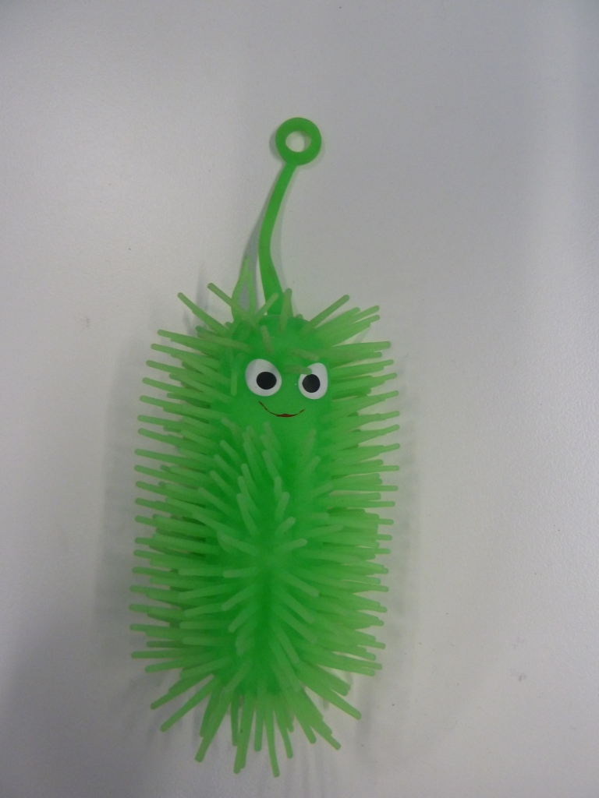 |  | 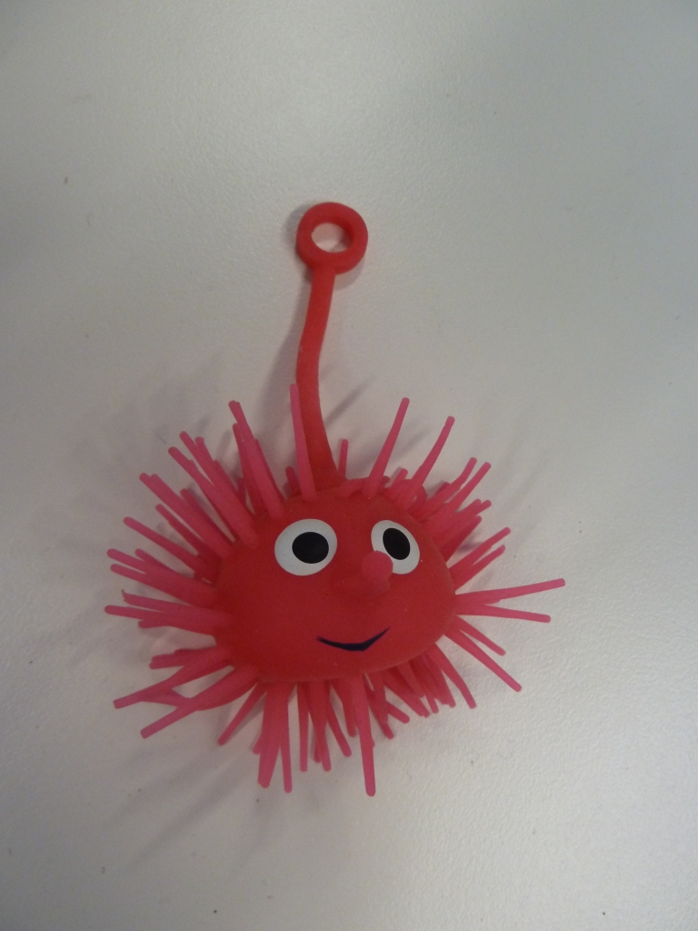
❐ CATERPILLAR YO-YO WATER BALL  Description: Green caterpillar-shaped spiky Yo-Yo Water Ball. |  | ❐ SMALL YO-YO WATER BALL  Description: Small round spiky Yo-Yo Water Ball.
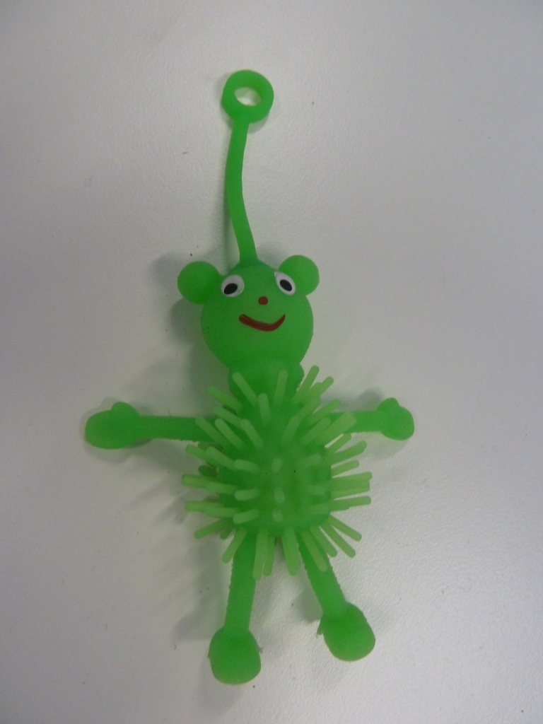 |  | 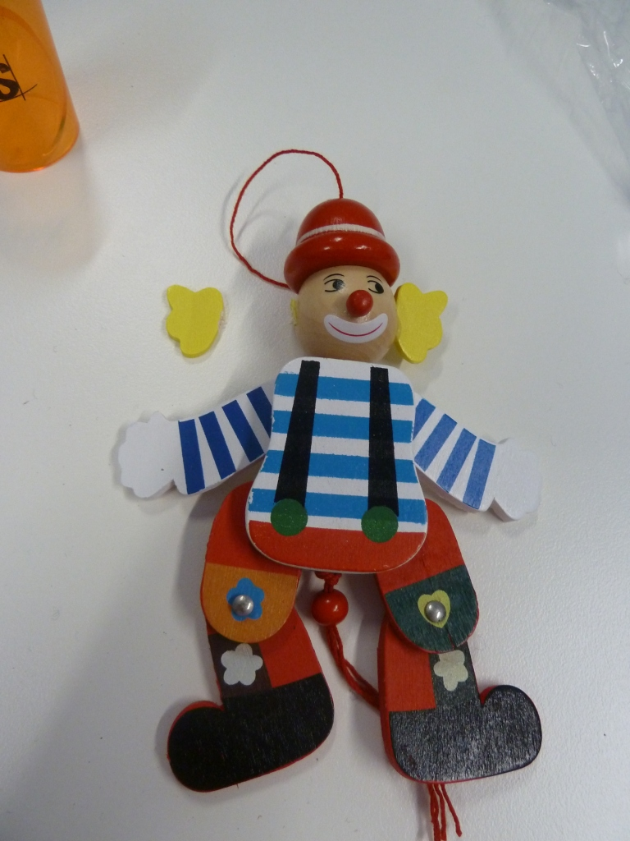
❐ MAN YO-YO WATER BALL  Description: Green man-shaped spiky  Yo-Yo Water Ball. |  | ❐ PULL DOWN CLOWN  Description: Coloured clown-shaped wooden toy.
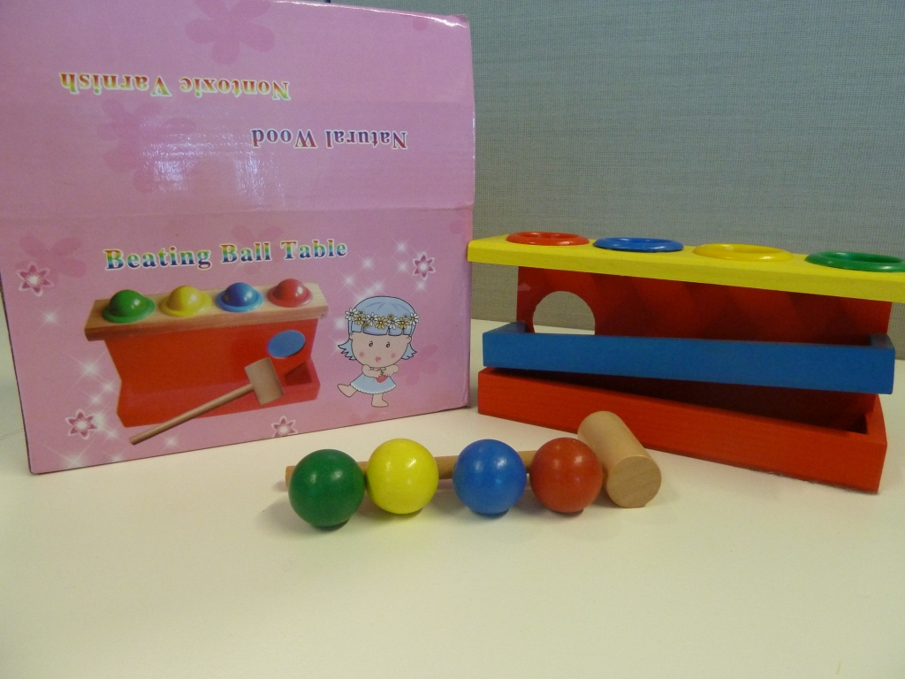 |  | 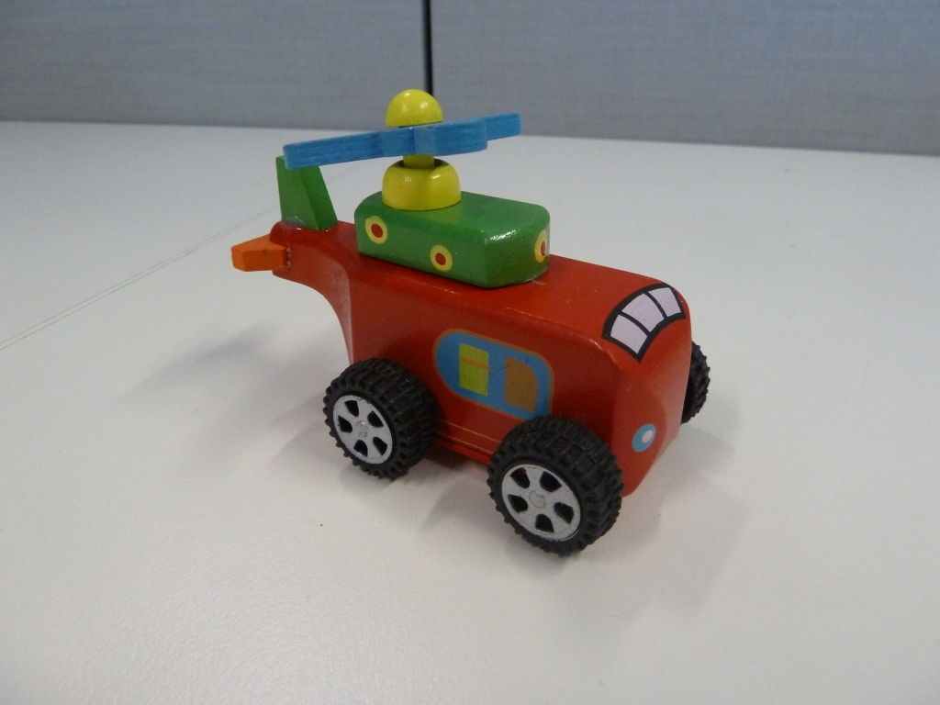
❐ “BEATING BALL TABLE”  Description: Coloured wooden pounding toy. |  | ❐ MINI WOODEN HELICOPTER  Description: Coloured helicopter-shaped wooden toy.

ANNEXURE “B”
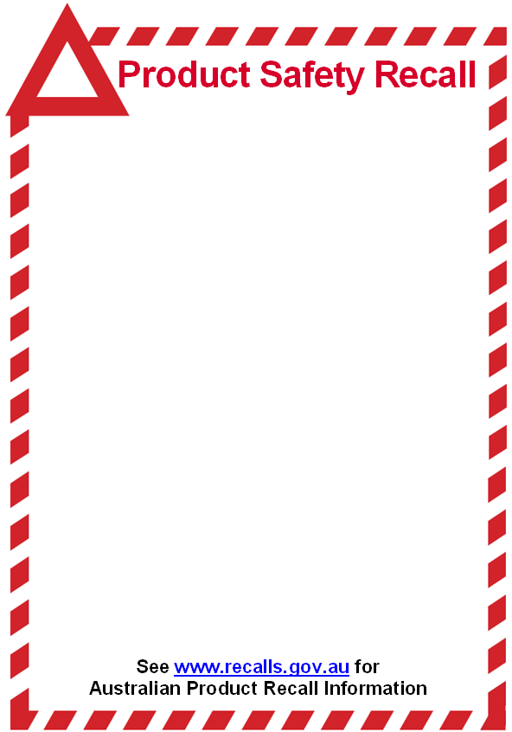

YO-YO WATER BALLS and WOODEN TOYS
Sold by ZAPATIN IMPORTS PTY LTD (ACN 137 282 663)
between November 2008 and November 2012.

Defect:
- The Yo-Yo Balls have an elastic cord extendable to at least 500 mm in length.
- The wooden toys contain small parts, or can break into small parts, in normal foreseeable use.

Hazard:
- Paragraph (a) above poses a strangulation hazard.
- Paragraph (b) above poses a choking hazard because of small parts.

What to do: Consumers should immediately stop using the Yo-Yo Water Balls and wooden toys and contact Zapatin Imports Pty Ltd (ACN 137 282 663) for either an exchange or a full refund of the purchase price.

Contact details: You can contact Zapatin Imports Pty Ltd by telephoning (03) 9553 1008 or 0425 771 880, Monday to Friday between 9:00 am and 5:00 pm. Zapatin Imports Pty Ltd is located at 82 Keys Road, Cheltenham Victoria 3192.
BANNED YO-YO WATER BALLS and WOODEN TOYS
seized by Consumer Affairs Victoria

ANNEXURE “C”
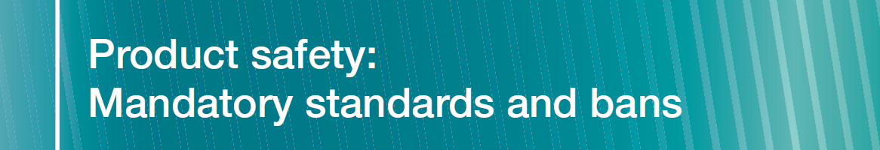

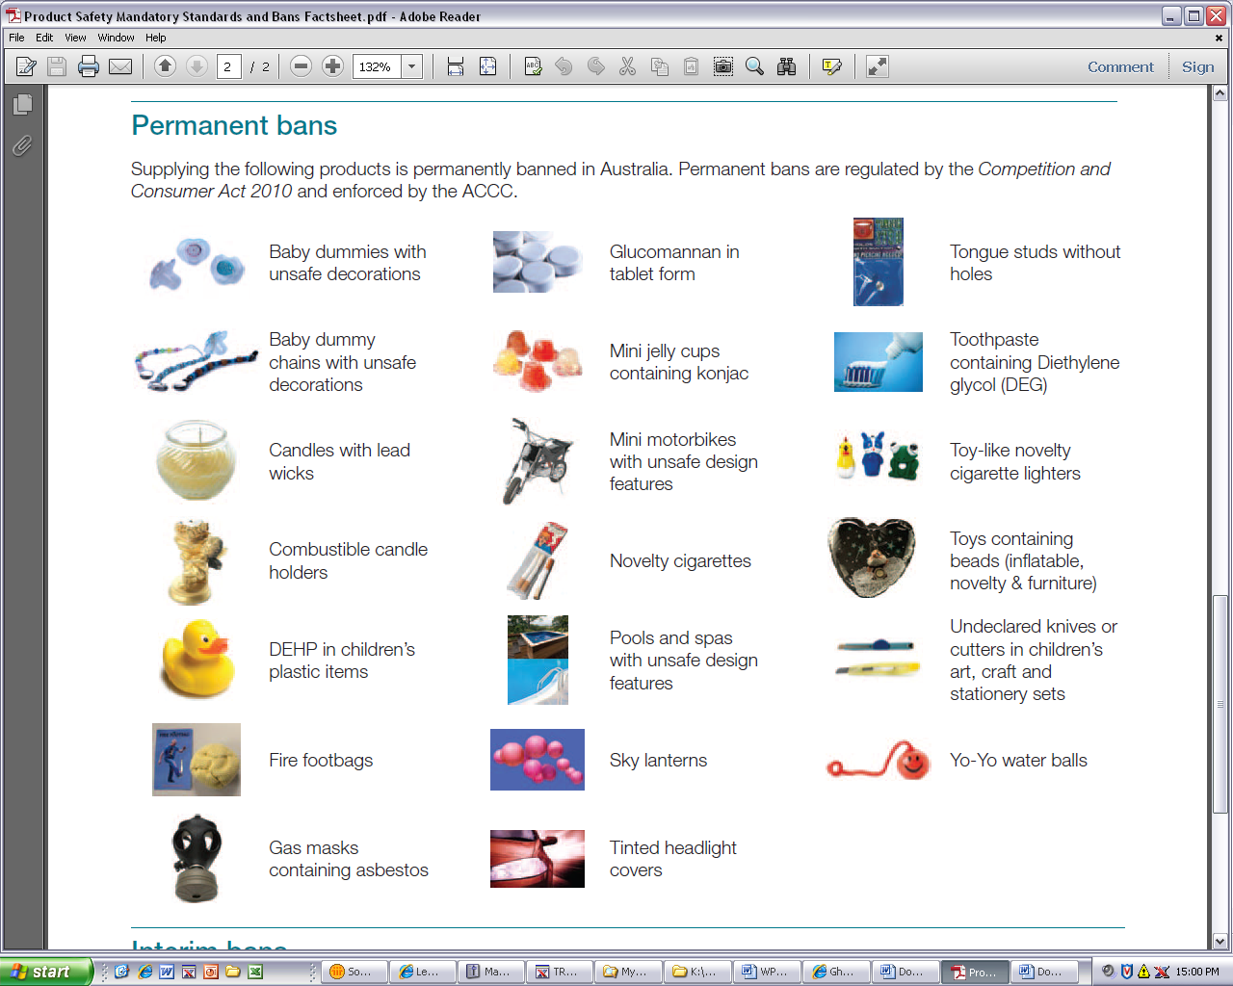
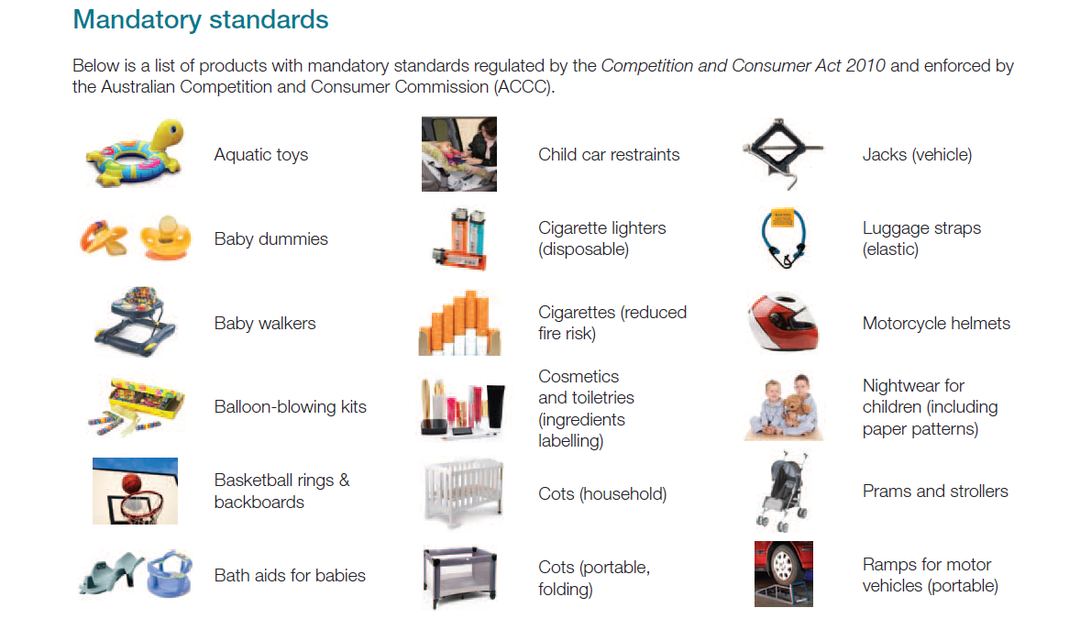
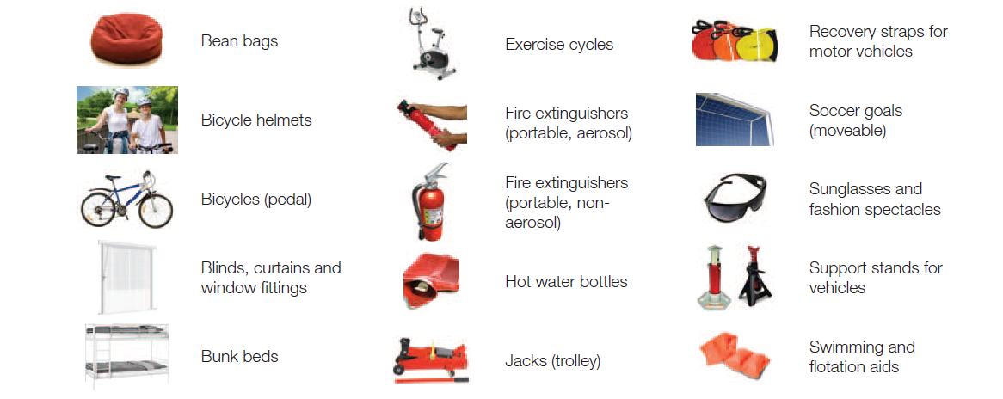
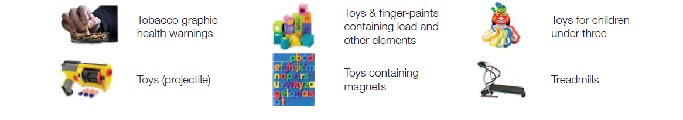

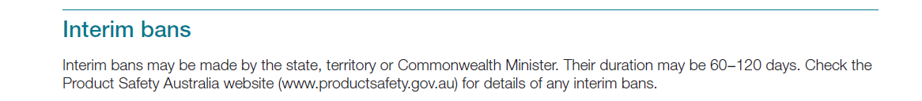

ANNEXURE “D”
COMPLIANCE PROGRAM
Interpretation
- In this Annexure:
  - “the Director” means the Director of Consumer Affairs Victoria;
  - “the ACL” means the Australian Consumer Law, being Schedule 2 to the Competition and Consumer Act 2010 (C’th);
  - “commencement date” means the date of the Court Order in this proceeding;
  - “the company” means Zapatin Imports Pty Ltd (ACN 137 282 663);
  - “Compliance Officer” means the person appointed under paragraph 2 below;
  - “Company Program” means the steps taken by the company to comply with the Court Order in relation to the Compliance Program;
  - “Court Order” means the final Orders of the Magistrates’ Court of Victoria in this proceeding;
  - “Relevant Provisions” means the sections in Part 3-4 of the ACL;
  - “Risk Assessment” means the assessment required by paragraph 3 below;
  - “Risk Assessment Report” means the report required by paragraph 4 below; and
  - “Training” means the training required by paragraph 6 below.
Compliance Officer
- The company must, within one month of the commencement date of the Court Order, appoint a director of the company, as its Compliance Officer, with responsibility for ensuring that the requirements concerning risk assessment and training, and product safety compliance procedures set out in the document are implemented and maintained.
Risk Assessment and Training
- The Compliance Officer must, within one month of the commencement date of the Court Order, conduct a risk assessment or appoint a person who has experience with mandatory standards and compliance systems to conduct a risk assessment to:
  - identify the areas of the company’s business where it is at risk of contravening the Relevant Provision;
  - assess the likelihood of any such contravention re-occurring;
  - identify where there are deficiencies in the company’s procedures for managing such risk;
  - making findings concerning sub-paragraphs (a) to (c) above;
  - make recommendations for action having regard to sub-paragraphs (a) to (d) above; and
  - implement the recommendations within one month of the risk assessment exercise.
- The assessor must set out the findings of the risk assessment exercise in a written report (Risk Assessment Report) within two months of the conclusion of the risk assessment exercise and provide a copy of the Risk Assessment Report to the Director or his nominee.
- The Compliance Officer must, at the time of the risk assessment exercise, subscribe to the Product Safety Australia Web Alerts [product-safety-alerts@accc.gov.au] to ensure that any new regulations or restrictions affecting goods that the company is or may be supplying in the future are brought to his attention for requisite compliance systems to be implemented.
Training
- The Compliance Officer must, after the risk assessment exercise, receive practical training regarding the product safety provisions in Parts 3-3 and 3-4 of the ACL and that the practical training include the areas of the company’s business where it is at risk or is likely to be at risk of contravening the Relevant Provision, as identified in the Risk Assessment Report.
- The company will ensure that the training is administered by a person who has experience with mandatory standards and compliance systems.
- The company will within the time provided for in the Court Order after the completion of practical training take all reasonable and necessary steps to obtain a written statement from the trainer and to provide such statement, in writing, to the Director, or his nominee, confirming the completion of the practical training.
Product Safety Compliance System
- The Compliance Officer must:
- satisfy himself that his supplier has the capacity to meet the requirements of all relevant and applicable:
- mandatory safety or information standards; and/or
- interim or permanent ban orders –
affecting goods that the company is or may be supplying in the future (“the Standards”); and
- ensure that the company keeps records of all orders for goods made in the future and that each such order must specify that goods to be acquired for supply by the company, in future, must conform with the requirements of the Standards.
- The company will:
- ensure that:
- all goods of the type of class to which the Standards apply acquired by the company for supply, are tested by a competent NATA testing authority to confirm that they conform to the Standard; and
- goods of the type of class to which the Standards apply are not supplied by the company unless the they have been tested as provided for in paragraph (i) above and conform with the relevant and applicable Standards;
- develop a checklist setting out the labelling requirements of the relevant and applicable Standards and use such checklist in line with a procedure developed for batch checking when goods arrive from suppliers;
- withdraw goods of the type of class to which the Standards apply from supply until such time they conform with the relevant and applicable Standards;
- maintain records of such checklist; and
- develop and implement a public complaint handling system and make such complaint handling system accessible from any website of which the company is the Registrant and upon which the company advertise or offers for supply, goods.
- Further, the Compliance Officer must:
- monitor that the checklists have been completed after the arrival of each batch of goods of the type of class to which the Standards apply and that the obligations and procedures provided for under paragraph 10 above are applied to such goods where non-conformance with the relevant and applicable Standards is detected;
- maintain up-to-date copies of all prescribed consumer product safety Standards that relate to products that the company supplies; and
- maintain files (or soft copies) of:
  - Order forms;
  - Testing results;
  - Checklist procedures;
  - Completed visual checklists; and
  - Risk assessments.
- The company must, within the periods or on the dates provided for in the Court Order, provide the Director with the required documents or information.

合规方案
释义
- 本附录中：
  - “主任”是指维州消费者事务署主任；
  - “ACL”是指《2010年竞争与消费者法案》(联邦)附件2的《澳大利亚消费者法》；
  - “生效日期”是指承诺书第38条规定的承诺开始生效的日期；
  - “公司”是指 means Zapatin Imports Pty Ltd (ACN 137 282 663)；
  - “合规负责人”是指依据下文第2条任命的人员；
  - “公司计划”是指公司为遵守针对合规方案所做出之承诺而采取的措施；
  - “承诺”是指公司及其董事或秘书 company and its director Ms Nuo Xing; 依据ACL第218节之规定，以书面形式向主任做出的承诺；
  - “相关规定”是指ACL第106节和第118节；
  - “风险评估”是下文第3条规定的评估；
  - “风险评估报告”是下文第4条规定的报告；以及
  - “培训”是下文第6条规定的培训。
合规负责人
- 公司必须在承诺生效日期一个月内，任命一名公司董事担任合规负责人，负责确保承诺书所述之涉及风险评估与培训及产品安全合规流程的要求得到贯彻实施。
风险评估与培训
- 合规负责人必须在承诺生效日期一个月内，开展风险评估，或指定一名具备强制性标准和合规体系工作经验的人员负责开展风险评估，以：
- 鉴别公司业务中存在违反相关规定风险的领域；
- 评估任何此类违规行为再次发生的可能性；
- 鉴别公司流程存在缺陷的领域，以控制此类风险；
- 总结出上文(a)至(c)款的评估结果；
- 针对上文(a)至(d)款，提出行动措施建议；以及
- 在实施风险评估一个月内执行建议措施。
- 评估员必须在风险评估结束后两个月内，以书面报告形式详细陈述风险评估结果(风险评估报告)，并向主任或其指定代表提供一份风险评估报告副本。
- 合规负责人必须在实施风险评估时，订阅澳大利亚产品安全网站提醒
[product-safety-alerts@accc.gov.au]，
确保关注影响公司当前正在或以后可能供应之产品的新法规或限制规定，以实施必要的合规制度。
培训
- 合规负责人必须在风险评估结束后，接受ACL第3-3章和第3-4章有关产品安全规定的实际培训，该实际培训包括风险评估报告中提及的、存在或可能存在违反相关规定风险的公司业务领域。
- 公司应确保由具备强制性标准和合规体系经验的人员负责实施这项培训。
- 公司应在承诺书规定的期限内，在完成实际培训后采取一切合理必要措施，取得培训师关于确认已完成实际培训的书面声明，并以书面形式向主任或其指定代表提供此类声明。
产品安全合规体系
- 合规负责人必须：
- 明确供应商有能力满足以下所有影响公司当前正在或以后可能供应之产品的相关适用要求：
- 强制性安全或信息标准；和/或
- 临时或永久性禁令
- 确保公司妥善保管日后的所有产品订单记录，且每项此类记录必须详细规定，公司日后购买用于供应的产品必须符合标准的要求。
- 公司应：
- 确保：
- 公司购买用于供应、且属于标准适用范围之类别的所有产品，接受资质合格之NATA检测机构的检测，以确认此类产品符合标准规定；以及
- 对于属于标准适用范围之类别的产品，除非已按依据前述(i)款规定检测，并符合相关适用标准的规定，否则公司不得销售供应；
- 制作对照表，详细载明相关适用标准的标签要求，并在供应商送抵产品时，在批次检验过程中使用此对照表；
- 对于属于标准适用范围之类别的产品，除非符合相关适用标准，否则予以退出销售供应；
- 保管此类对照检验的记录；以及
- 制定并实施公众投诉处理体系，并采取措施，以便公众能通过公司注册及发布广告或供应产品的网站访问该投诉处理体系。
- 此外，合规负责人必须：
- 监督属于标准适用范围之类别的每批产品到货后完成对照检验，并履行前述第10条规定之适用于此类产品的义务和流程，以便从中检查出不符合相关适用标准的情况；
- 及时维护与公司供应之产品相关的所有消费产品安全标准规定；以及
- 保管如下档案(或软拷贝)：
  - 订单；
  - 检测结果；
  - 对照检验流程；
  - 已填写完毕的对照单；以及
  - 风险评估报告。
- 公司必须在承诺书规定的期限内或日期，向主任提供规定的文件或信息。

