Notice of personal documents left behind (SDA)
Residential Tenancies Act 1997, Part 12A
Specialist Disability Accommodation
Section 498ZZY

Note:
Use this form if you are a specialist disability accommodation (SDA) provider and the SDA resident (the resident) has left behind personal documents after vacating the SDA dwelling.
Enter text in spaces provided only.
You can download this notice at consumer.vic.gov.au/forms.

How to serve this notice
You can post this notice, deliver it personally to the resident between 8am and 6pm, or email it (with consent).
You must give this form to the resident and their guardian or administrator, if any.
You must also explain the notice in a language, mode of communication and terms the resident is likely to understand. If it will help the resident, you must explain it verbally and in writing.
If it will help the resident, you must also give a copy of the notice to their family member, carer, advocate or other chosen person.
If the resident has not chosen a support person, you can choose a person who is not your employee or representative to assist the resident.
You can only give this notice by email if you already have the resident’s written consent to receive notices and other documents this way.
You and the resident may have consented to electronic service of notices and other documents in the SDA residency agreement.

Telephone Interpreter Service
If you have difficulty understanding English, contact the Translating and Interpreting Service (TIS) on 131 450 (for the cost of a local call) and ask to be put through to an Information Officer at Consumer Affairs Victoria on
1300 55 81 81.
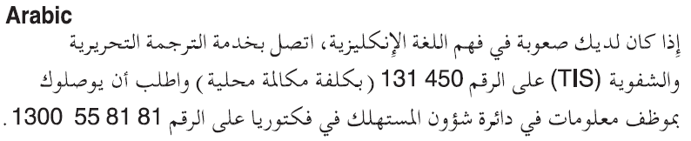
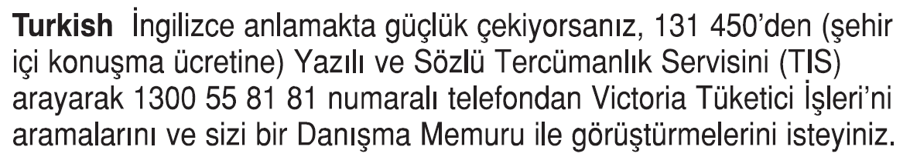
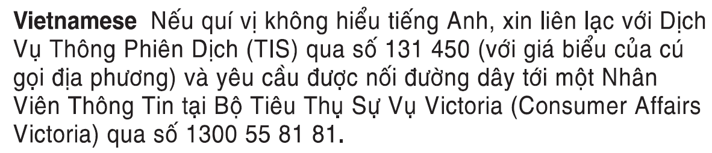
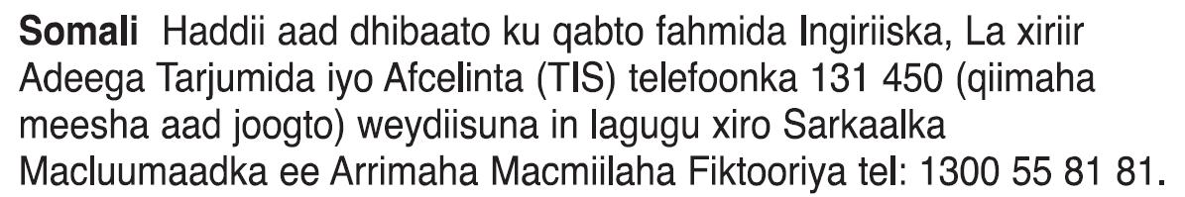
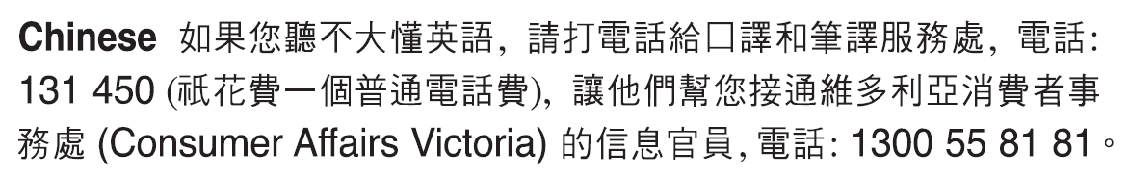
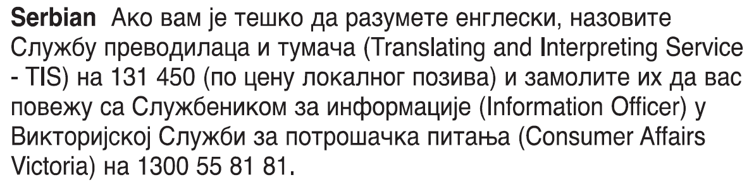
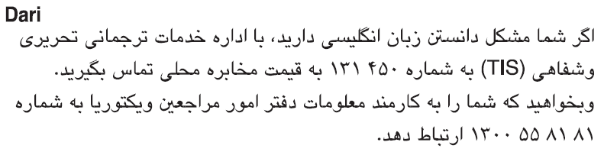
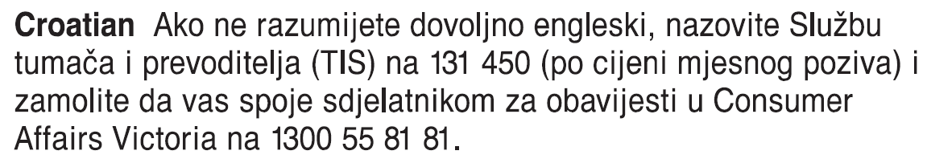
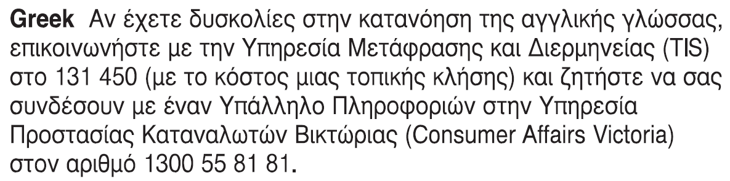
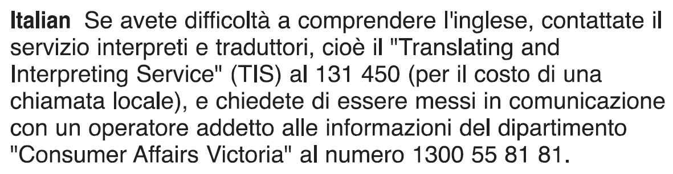 Information about renting is available in other languages at consumer.vic.gov.au/languages.

Notice of personal documents left behind (SDA) SDA resident’s copy
Residential Tenancies Act 1997 S498ZZY

Former SDA resident details
- This notice is given to:
(former resident/s name)
- A copy of this notice is also given to:
(if applicable, insert name and address of resident’s family member, carer, advocate, guardian, administrator or other chosen person)
- Regarding the SDA dwelling at:
(write address)
- Resident’s address:

SDA provider/mortgagee/owner details
- SDA provider:
(cannot be agent’s name)
- SDA provider address for serving documents:
(can be an agent’s address)
- Contact telephone numbers for SDA provider:
(can be agent’s telephone number)
Business hours:
After hours:

Personal documents left behind
- You vacated the dwelling on:
(dd/mm/yyyy)
/ /
and have left the following personal documents behind:
(describe documents)

Collection
- These personal documents may be collected from the following address:
(insert address)

Disposal
- I am required to keep your personal documents for 10 days from the date of this notice. The documents will be disposed of if not collected by:
(dd/mm/yyyy)
/ /
- Signature of SDA provider, their authorised officer or agent:
- Name of SDA provider, their authorised officer or agent signing this notice:

Notice of personal documents left behind (SDA) SDA resident support person’s copy
Residential Tenancies Act 1997 S498ZZY

Former SDA resident details
- This notice is given to:
(former resident/s name)
- A copy of this notice is also given to:
(if applicable, insert name and address of resident’s family member, carer, advocate, guardian, administrator or other chosen person)
- Regarding the SDA dwelling at:
(write address)
- Resident’s address:

SDA provider/mortgagee/owner details
- SDA provider:
(cannot be agent’s name)
- SDA provider address for serving documents:
(can be an agent’s address)
- Contact telephone numbers for SDA provider:
(can be agent’s telephone number)
Business hours:
After hours:

Personal documents left behind
- You vacated the dwelling on:
(dd/mm/yyyy)
/ /
and have left the following personal documents behind:
(describe documents)

Collection
- These personal documents may be collected from the following address:
(insert address)

Disposal
- I am required to keep your personal documents for 10 days from the date of this notice. The documents will be disposed of if not collected by:
(dd/mm/yyyy)
/ /
- Signature of SDA provider, their authorised officer or agent:
- Name of SDA provider, their authorised officer or agent signing this notice:

Notice of personal documents left behind (SDA) SDA provider’s copy
Residential Tenancies Act 1997 S498ZZY

Former SDA resident details
- This notice is given to:
(former resident/s name)
- A copy of this notice is also given to:
(if applicable, insert name and address of resident’s family member, carer, advocate, guardian, administrator or other chosen person)
- Regarding the SDA dwelling at:
(write address)
- Resident’s address:

SDA provider/mortgagee/owner details
- SDA provider:
(cannot be agent’s name)
- SDA provider address for serving documents:
(can be an agent’s address)
- Contact telephone numbers for SDA provider:
(can be agent’s telephone number)
Business hours:
After hours:

Personal documents left behind
- You vacated the dwelling on:
(dd/mm/yyyy)
/ /
and have left the following personal documents behind:
(describe documents)

Collection
- These personal documents may be collected from the following address:
(insert address)

Disposal
- I am required to keep your personal documents for 10 days from the date of this notice. The documents will be disposed of if not collected by:
(dd/mm/yyyy)
/ /
- Signature of SDA provider, their authorised officer or agent:
- Name of SDA provider, their authorised officer or agent signing this notice:

