Breach of duty notice to SDA provider
Residential Tenancies Act 1997, Part 12A
Specialist Disability Accommodation
Section 498ZP

Note
Use this form if you are a Specialist Disability Accommodation (SDA) resident and you are issuing a breach of duty notice to the SDA provider (the provider) for:
- failing to ensure that residents are treated with dignity and respect and given privacy
- failing to ensure that fixtures and fittings are in good repair
- unreasonably interfering with the resident’s right to privacy
- failing to ensure the security of the dwelling
- failing to minimise inconvenience or disruption to the resident during repairs or renovations
- failing to ensure repairs or renovations are carried out in a timely manner and by someone who is suitably qualified
- unreasonably refusing to allow the resident to keep a pet.
Give this form to the SDA provider.
Enter text in spaces provided only.
This document is available for download at consumer.vic.gov.au/forms.

How to use this form
- Identify your reason for providing a breach of duty notice
Read the reasons provided in the table on page 3. These are the breaches of duty listed in the Act under which you can give a breach of duty notice.
Select the correct reason and write down the section number in box 8.
- Complete questions 1 to 9
You must complete all boxes.
- Sign at 10

How to serve this notice
The notice must be given by post, or by delivering it personally to the provider between 8am and 6pm, or by email (with consent).
You can only give this notice by email if you already have the provider’s written consent to receive notices and other documents this way.
You and the provider may have consented to electronic service of notices and other documents in the SDA residency agreement.

Telephone Interpreter Service
If you have difficulty understanding English, contact the Translating and Interpreting Service (TIS) on 131 450 (for the cost of a local call) and ask to be put through to an Information Officer at Consumer Affairs Victoria on
1300 55 81 81.
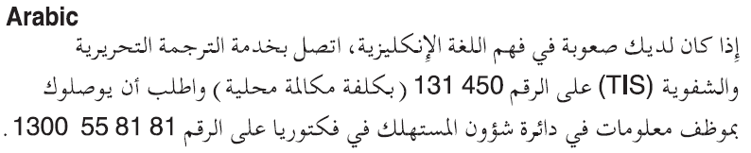
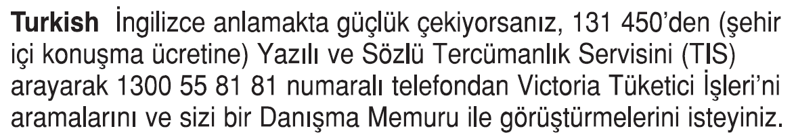
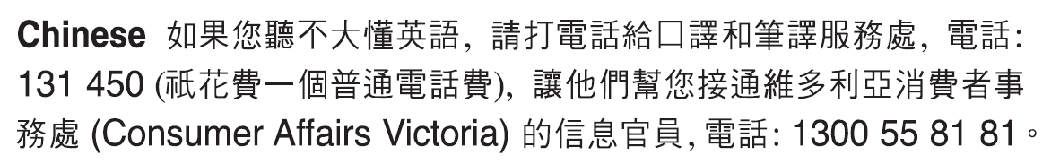
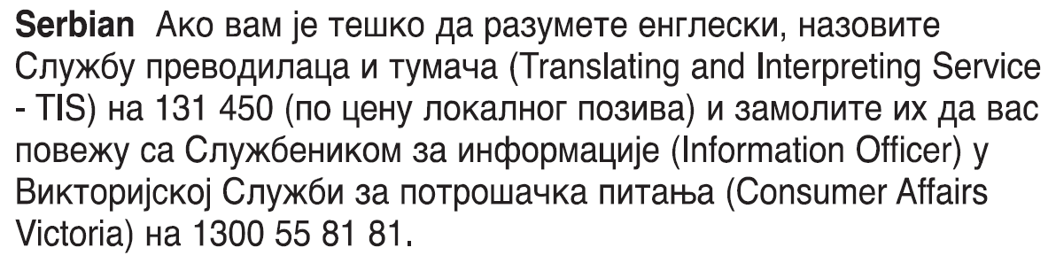
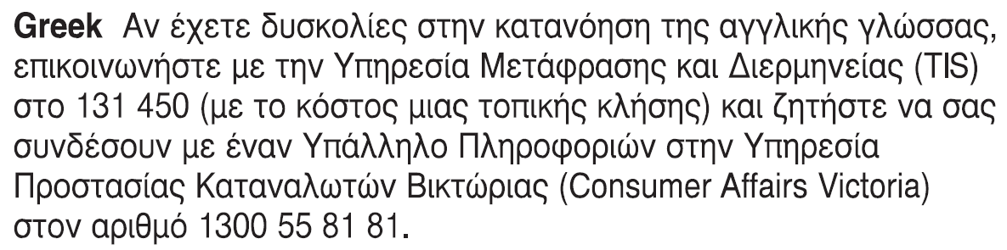
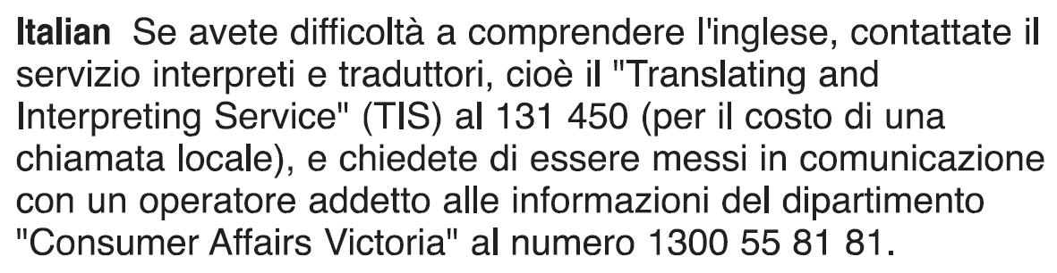
Information about renting is available in other languages at consumer.vic.gov.au/languages.

Breach of duty notice to SDA provider

Reasons for giving breach of duty notice
Reason and section number | Detail
Failing to ensure that residents are treated with dignity and respect and given privacy  498M(1)(a) | You have not taken reasonable measures to ensure SDA residents are treated with dignity and respect and to protect their privacy.
Failing to ensure that fixtures and fittings are in good repair  498M(1)(b) | You have not ensured that fixtures and fittings are maintained in good repair.
Interfering with the resident’s right to privacy  498M(1)(c) | You have unreasonably interfered with the resident’s right to privacy.
Failing to install fixtures required by the SDA resident to assist their daily living or proper use and enjoyment of the SDA dwelling  498M(1)(ca) | You have not installed fixtures and fittings required by the SDA resident to assist their daily living or proper use and enjoyment of the SDA dwelling.
Failing to ensure the security of the dwelling  498M(1)(d) | You have not taken reasonable measures to ensure the dwelling is secure.
Failing to minimise inconvenience or disruption to the resident during repairs or renovations  498M(1)(e) | You have carried out repairs or renovations to the dwelling without minimising the disruption to the resident.
Failing to ensure repairs or renovations are carried out in a timely manner and by someone who is suitably qualified  498M(1)(f) | You have not taken reasonable steps to ensure repairs or renovations are carried out promptly and by someone who is suitably qualified.
Unreasonably refusing consent for a pet  498M(2) | You have unreasonably refused consent for the resident to keep a pet at the dwelling.

Breach of duty notice SDA resident’s copy
Residential Tenancies Act 1997 S498ZP

SDA provider details
- This notice is given to:
(SDA provider’s name)
- SDA provider’s address: (can be an agent’s address)

SDA resident details
- SDA resident’s name:
- Regarding the SDA dwelling at:
(write address)
- Address for serving documents:
(if the same as in 4, write ‘as above’)
- SDA resident’s contact telephone numbers:
Business hours:
After hours:

Service details
- This notice is given:
(mark one method only and if posted note the delivery speed)
By hand:
By registered post:
By ordinary post:
By email:
Insert email address:
(if applicable)
On:  (dd/mm/yyyy) | / /

Reason for breach of duty notice
- You have breached your duty as SDA provider because:
(write the section number and words from the table on page 3)
The loss or damage caused is:
Compensation or compliance required:
I require you to remedy the breach within 14 days after receiving this notice by:
Or pay me compensation of: ($)
You must not commit a similar breach again. If you do not comply with this notice I may apply to the Victorian Civil and Administrative Tribunal (VCAT) for a compensation or compliance order or I may give a notice of intention to vacate under section 498ZZA.
- Details are attached to this notice:
(for example: receipts, other evidence)
Yes:
No:
- Signature of SDA resident:

Breach of duty notice SDA resident support person’s copy
Residential Tenancies Act 1997 S498ZP

SDA provider details
- This notice is given to:
(SDA provider’s name)
- SDA provider’s address: (can be an agent’s address)

SDA resident details
- SDA resident’s name:
- Regarding the SDA dwelling at:
(write address)
- Address for serving documents:
(if the same as in 4, write ‘as above’)
- SDA resident’s contact telephone numbers:
Business hours:
After hours:

Service details
- This notice is given:
(mark one method only and if posted note the delivery speed)
By hand:
By registered post:
By ordinary post:
By email:
Insert email address:
(if applicable)
On:  (dd/mm/yyyy) | / /

Reason for breach of duty notice
- You have breached your duty as SDA provider because:
(write the section number and words from the table on page 3)
The loss or damage caused is:
Compensation or compliance required:
I require you to remedy the breach within 14 days after receiving this notice by:
Or pay me compensation of: ($)
You must not commit a similar breach again. If you do not comply with this notice I may apply to the Victorian Civil and Administrative Tribunal (VCAT) for a compensation or compliance order or I may give a notice of intention to vacate under section 498ZZA.
- Details are attached to this notice:
(for example: receipts, other evidence)
Yes:
No:
- Signature of SDA resident:

Breach of duty notice SDA provider’s copy
Residential Tenancies Act 1997 S498ZP

SDA provider details
- This notice is given to:
(SDA provider’s name)
- SDA provider’s address: (can be an agent’s address)

SDA resident details
- SDA resident’s name:
- Regarding the SDA dwelling at:
(write address)
- Address for serving documents:
(if the same as in 4, write ‘as above’)
- SDA resident’s contact telephone numbers:
Business hours:
After hours:

Service details
- This notice is given:
(mark one method only and if posted note the delivery speed)
By hand:
By registered post:
By ordinary post:
By email:
Insert email address:
(if applicable)
On:  (dd/mm/yyyy) | / /

Reason for breach of duty notice
- You have breached your duty as SDA provider because:
(write the section number and words from the table on page 3)
The loss or damage caused is:
Compensation or compliance required:
I require you to remedy the breach within 14 days after receiving this notice by:
Or pay me compensation of: ($)
You must not commit a similar breach again. If you do not comply with this notice I may apply to the Victorian Civil and Administrative Tribunal (VCAT) for a compensation or compliance order or I may give a notice of intention to vacate under section 498ZZA.
- Details are attached to this notice:
(for example: receipts, other evidence)
Yes:
No:
- Signature of SDA resident:

