Notice to vacate to resident/s of SDA enrolled dwellings
Residential Tenancies Act 1997 (the Act), Part 12A
Specialist Disability Accommodation
Section 498ZX, 498ZZD, 498ZZCA

Note:
- Use this form to give notice to vacate if you are a Specialist Disability Accommodation (SDA) provider and you have a Part 12A SDA residency agreement with an SDA resident (the resident) in respect of a dwelling or room.
- If you have a residential tenancy agreement under Part 2 then you must use a different form.
- This form may be used for an SDA resident who is a National Disability Insurance Scheme (NDIS) recipient and an SDA resident who is a continuity of support accommodation client under the Commonwealth Continuity of Support Programme.
- This form must be provided to both the Specialist Disability Accommodation (‘SDA’) resident (the resident) and the resident’s guardian or administrator, if any.
- Enter text in spaces provided only. This form will be invalid if you remove or change any questions or other text.
- This document is available for download at consumer.vic.gov.au/forms.

How to use this form

1. Identify your reason
Read the reasons for giving notice to vacate on pages 3 to 4 and identify the correct reason for your circumstances. Check whether there are additional requirements involved, for example, issuing of a notice of temporary relocation.
The number beside each reason is the relevant section and sub-section of the Act.

2. Consult the Act
You should consult Part 12A of the Act to make sure that you are entitled to give a notice to vacate.

3. Minimum time for the notice
Under law, the resident must be given 90 days’ notice.
The minimum notice period commences on the day after the notice is given and the first available termination date is the day after the minimum notice period expires.
Note: Australia Post has three different speeds for mail delivery – express, priority and regular. If you send this notice by post, you must take into account the extra days it takes for the notice to be delivered. For more information about postal delivery options and times, visit the Australia Post website.
.

4. Complete the notice
- You must complete all boxes on the notice.
- Write your reason for giving the notice in box 10, You must use write the section number and the exact words given in the Table on pages 3 to 5. You must insert dates and monetary amounts where a line appears in the reason.
- Write the factual details that support giving the notice in box 11.
Important: You must also include enough information in box 11 to allow the resident to understand why you are giving the notice and the facts you claim are the basis for giving the notice. It is not sufficient to merely write the section number and state the reason from the Act. If you do not provide enough details in box 9, the notice to vacate may be found invalid if challenged by the resident at the Victorian Civil and Administrative Tribunal (VCAT).
For example, if you are giving a notice to vacate because of danger [s498ZX(1)(b)]:
Box 10
S498ZX(1)(b) – you have endangered the safety of other SDA residents or staff at the SDA enrolled dwelling.

Box 11
[Insert factual details to explain why you are giving the notice to vacate – how the SDA resident’s conduct has endangered the safety of other residents or staff]

6. Sign at 13 and write your name at 14

5. When the form is complete
- Tear out the top form (SDA resident’s copy) and send to the resident.
- You must send a second copy to the resident’s guardian or administrator if any.
- You must notify the Chief Executive Officer of the NDIA, the Public Advocate and the Director of Consumer Affairs Victoria and the Public Advocate within 24 hours of the notice being given to a resident who is an SDA recipient.
- You must notify the Public Advocate and the Director within 24 hours of the notice being given to a resident who is a CoS supported accommodation client.
- You must also give a copy to the resident’s family member, carer, advocate or other support chosen person, where it would assist the resident. If the resident has not chosen a support person, you can choose a person to assist the resident that is not your employee or representative.
- Keep the last copy for your records..
- For more information, see ‘How to give this notice’ on page 4.

Telephone Interpreter Service
If you have difficulty understanding English, contact the Translating and Interpreting Service (TIS) on 131 450 (for the cost of a local call) and ask to be put through to an Information Officer at Consumer Affairs Victoria on
1300 55 81 81.
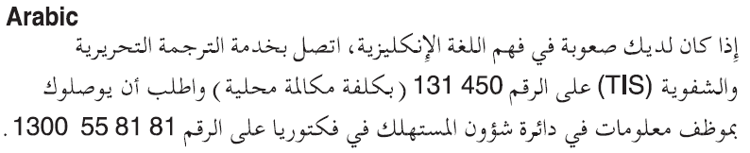
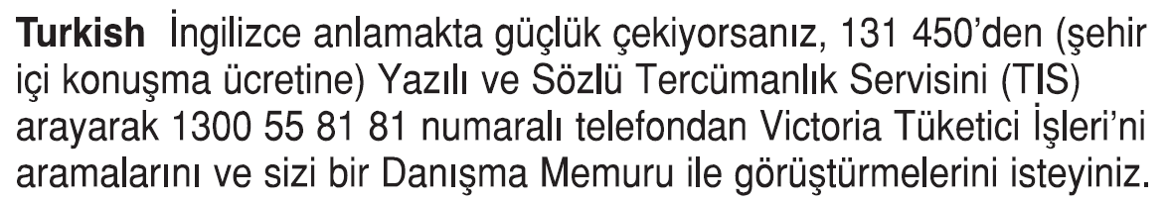
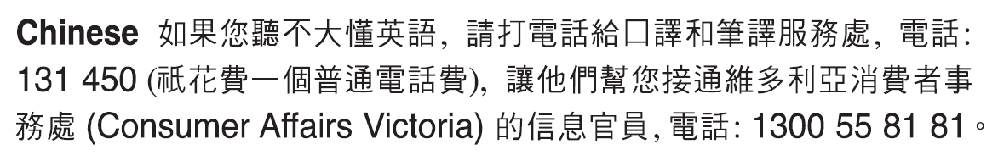
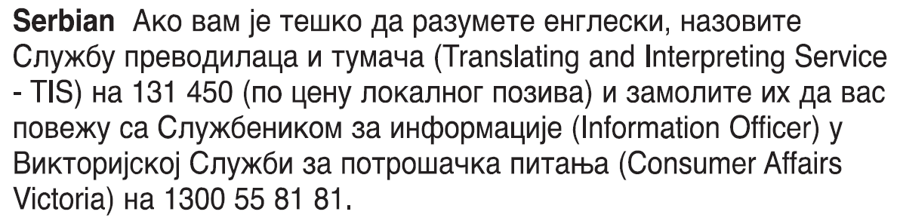
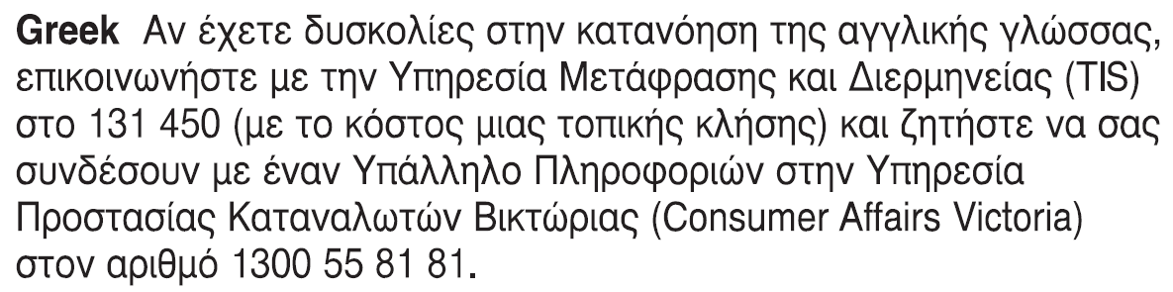
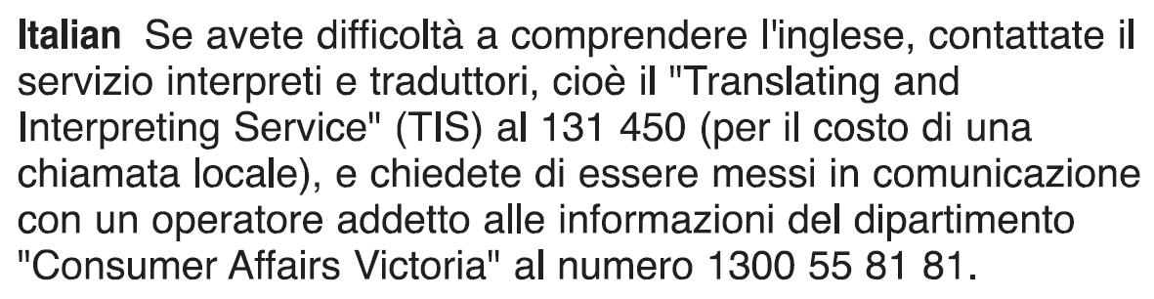 Information about renting is available in other languages at consumer.vic.gov.au/languages.

Notice to vacate to resident/s of SDA enrolled dwellings under Part 12A

Reasons for giving notice to vacate
Reason  Section number | Detail | Additional requirements
Unpaid rent  498ZX(1)(a) | You owe at least 14 days unpaid rent to the SDA provider. Rent is paid up to, and including _ /_ /_. $_ is owed | The resident must have first been given a breach of duty notice for not paying their rent and allowed 14 days to remedy the breach.
Danger  498ZX(1)(b) | You have endangered the safety of other SDA residents or staff at the SDA enrolled dwelling. | The resident must have been given a temporary relocation notice for the same reason 24 hours prior to this notice.  The SDA provider must believe the conduct constituting the breach is likely to reoccur to give this notice.  The SDA provider must take reasonable steps to notify the resident’s Supported Independent Living provider as soon as possible.
Disruption  498ZX(1)(c) | You are causing causing serious disruption to the proper use and enjoyment of the SDA enrolled dwelling by other residents. | The resident must have been given a temporary relocation notice for the same reason 24 hours prior to this notice.  The SDA provider must believe the conduct constituting the breach is likely to reoccur to give this notice.  The SDA provider must take reasonable steps to notify the resident’s Supported Independent Living provider as soon as possible
Danger to self  498ZX(1)(d) | You are a danger to themselves and can no longer be appropriately supported in the SDA enrolled dwelling. | The resident must have been given a temporary relocation notice for the same reason 24 hours prior to this notice.  The SDA provider must believe the conduct constituting the breach is likely to reoccur to give this notice.  The SDA provider must take reasonable steps to notify the resident’s Supported Independent Living provider as soon as possible.
Lack of appropriate support  498ZX(1)(e) | You can no longer be appropriately supported in the SDA enrolled dwelling. | The resident must have been given a temporary relocation notice for the same reason 24 hours prior to this notice.  The SDA provider must believe the conduct constituting the breach is likely to reoccur to give this notice  The SDA provider must take reasonable steps to notify the resident’s Supported Independent Living provider as soon as possible.
Serious damage  498ZX(1)(f) | You have caused serious damage or have destroyed any part of the SDA enrolled dwelling. | The resident must have been given a temporary relocation notice for the same reason 24 hours prior to this notice.  The SDA provider cannot give the notice if fair wear and tear, accidental damage, reasonable use of any aids or equipment, or any behaviour arising from the resident’s disability significantly contributed to the damage. The SDA provider must believe the conduct constituting the breach is likely to reoccur to give this notice.  .  The SDA provider must take reasonable steps to notify the resident’s Supported Independent Living provider as soon as possible.
Used for illegal purposes  498ZX(1)(g) | You have used the SDA enrolled dwelling for an illegal purpose. | The resident must have been given a temporary relocation notice for the same reason 24 hours prior to this notice.  The SDA provider must believe the conduct constituting the breach is likely to reoccur to give this notice.
Repairs to dwelling  498ZX(1)(h) | The SDA provider intends to repair, renovate or reconstruct the SDA enrolled dwelling immediately after the termination date and the SDA provider has obtained all necessary permits to carry out the work, and the work cannot be properly carried out unless you vacate the SDA enrolled dwelling | The resident must have been given a temporary relocation notice for the same reason 24 hours prior to this notice.  Important  Where:  - the proposed repairs, renovations or reconstruction will affect the SDA resident’s area or room but will not affect all areas or rooms in the dwelling; and  - an area or room equivalent to the SDA resident’s area or room at an equivalent rent is available in the dwelling  A notice must not be given unless the SDA provider has first offered an equivalent area or room to the SDA resident and the resident has refused to occupy that area or room.  The notice must be accompanied by supporting documentary evidence approved by the Director of Consumer Affairs (if any).
Demolition of dwelling  498ZX(1)(ha) | The SDA provider intends to demolish the dwelling immediately after the termination date and the SDA provider obtained all necessary permits to carry out the work, and the work cannot be properly carried out unless you vacate the SDA enrolled dwelling
Dwelling to be sold  498ZX(1)(k) | The SDA dwelling is to be sold or offered for sale with vacant possession (that is, there are no other residents living in the dwelling) | The notice must be accompanied by supporting documentary evidence approved by the Director of Consumer Affairs (if any).
Failure to comply with VCAT order  498ZX(1)(l) | You have failed to comply with a VCAT order made under section 498ZS. | The SDA provider cannot give the notice if reasonable use of any aids or equipment or any behaviour arising from the resident’s disability significantly contributed to resident’s failure to comply with the VCAT order.
Mortgagee entitled to possession gives notice to vacate  498ZZD | I am the mortgagee of the SDA enrolled dwelling and I am entitled to possession of the dwelling or to sell the dwelling under a mortgage. | The mortgagee must sign the notice and give a copy to the SDA resident and the SDA recipient’s guardian or administrator, where applicable. The mortgagee must notify the NDIA CEO, Public Advocate and Director of the details of the notice within 24 hours of the notice being given to the SDA recipient.
Owner of the SDA enrolled dwelling gives notice to vacate  498ZZCA | I am the owner of the SDA enrolled dwelling and am exercising my right to issue a notice to vacate, recover possession of the dwelling or give a breach of duty notice. | A notice under this section does not have effect unless it includes a termination date which is after the day on which the SDA provider’s interest in the premises ends.

How to serve this notice
The notice must be given by post, by delivering it personally to the resident between 8 am and 6 pm, or by email (with consent).
You can only give this notice by email if you already have the resident’s written consent to receive notices and other documents this way. You and the resident may have consented to electronic service of notices and other documents in the SDA residency agreement.
You must give a copy of the notice to the resident’s guardian or administrator if any.
You must also explain the notice of entry in a language, mode of communication and terms the resident is likely to understand. If it will help the resident, you must explain it orally and in writing.
If it will help the resident, you must also give a copy of the notice to the resident’s family member, carer, advocate or other chosen support person. If the resident has not chosen a support person, you can choose a person to assist the resident that is not your employee or representative.
Note you must notify the following offices within 24 hours of giving a notice of temporary relocation to a SDA resident. Failure to do so is an offence punishable by a fine:
Notice of Temporary Relocation given to SDA resident who is a NDIS participant:
Notify: Chief Executive Officer of the National Disability Insurance Agency
and
The Office of the Public Advocate
and
The Director of Consumer Affairs Victoria
Notice of Temporary Relocation given to SDA resident who is receiving continuity of supports under the Commonwealth Continuity of Support Programme
Notify: The Office of the Public Advocate
and
The Director of Consumer Affairs Victoria
If you need help with this notice, visit the Renting section – Consumer Affairs Victoria website (consumer.vic.gov.au/renting)
or call the CAV Helpline on 1300 55 81 81.

Notice to vacate to resident/s of SDA enrolled dwellings under part 12A SDA Resident’s copy
Residential Tenancies Act 1997 S498ZX, 498ZZD, 498ZZCA

SDA resident details
- This notice is given to (resident/s name):
- A copy of this notice is also given to: (if applicable, insert name and address of resident’s family member, carer, advocate, guardian, administrator or other chosen person)
- Regarding the SDA dwelling at: (write address)
- Resident’s address
(if same address as 2, write ‘as above’)

SDA provider/mortgagee/owner details
- I am giving you this notice as: (mark one only)
the SDA provider:
the mortgagee:
the owner:

- SDA provider/mortgagee/owner name: (cannot be agent’s name)
- SDA provider/mortgagee/owner address for serving documents: (can be an agent’s address)
- Contact telephone numbers for SDA provider/mortgagee/owner: (can be agent’s telephone number)
Business hours:
After hours:

Termination date
- The Residential Tenancies Act 1997 requires me to give you at least 90 days to vacate:
I require you to vacate on: | / /

Reason for notice to vacate
- Write the section number and the reason, using the words provided in the table on pages 3 to 5 ‘Reasons for giving notice to vacate’.
Note: If given under 498ZX(1)(h) or (k), this notice must be accompanied by supporting documentary evidence approved by the Director of Consumer Affairs (if any).

Outline of circumstances giving rise to this notice
- Please provide details of the circumstances that support the issuing of this notice:

Service details
- This notice is given: (mark one method only and if registered post note the delivery speed)
by hand:
by registered post:
by email:
Insert email address:
(if applicable)
on this date: | / /

Note: A copy of this notice must be given to the resident’s guardian or administrator (if any).

- Signature of SDA provider, their authorised officer or agent:
- Name of SDA provider, their authorised officer or agent signing this notice:

SDA resident please note
- If you have been given notice to vacate you may apply to the Victorian Civil and Administrative Tribunal (VCAT) to challenge the notice under s498ZZC. You must apply within 90 days of the date of this notice.
- It is recommended that you obtain independent legal advice if you wish to challenge the notice to vacate in VCAT.
- Alternatively, you may be able to end the tenancy earlier than the date the SDA provider has given you in the Notice to vacate. Under s498ZZA you can give the SDA provider written notice of your intention to vacate at any time and specify your own termination date. You can do this using a Notice to SDA provider form which is available via consumer.vic.gov.au/renting
- If you need help with this notice, call the Consumer Affairs Victoria Helpline on 1300 55 81 81 or visit consumer.vic.gov.au/renting

Notice to vacate SDA resident support person’s copy
Residential Tenancies Act 1997 S498ZX; Regulation *

Resident details
- This notice is given to (resident’s name):
- A copy of this notice is also given to: (if applicable, insert name and address of resident’s family member, carer, advocate, guardian, administrator or other chosen person)
- Regarding the SDA dwelling at: (write address)
- Resident’s address
(if same address as 2, write ‘as above’)

SDA provider’s details
- SDA provider’s name:
- SDA provider address for serving documents:
- Contact telephone numbers for SDA provider:
Business hours:
After hours:

Termination date
- The Residential Tenancies Act 1997 requires me to give you at least 90 days to vacate:
I require you to vacate on: | / /

Reason for notice to vacate
- Insert the section number of the Residential Tenancies Act 1997 and the reason for the notice to vacate.
- This notice is given: (mark one method only and if registered post note the delivery speed)
by hand:
by registered post:
by email:
Insert email address:
(if applicable)
on this date: | / /
- Signature of SDA provider:
- Name of SDA provider:

SDA resident please note
- If you have been given notice to vacate you may apply to the Victorian Civil and Administrative Tribunal (VCAT) to challenge the notice under s498ZZC. You must apply within 90 days of the date of this notice.
- Alternatively, you may be able to end the tenancy earlier than the date the SDA provider has given you in the Notice to vacate. Under s498ZZA you can give the SDA provider written notice of your intention to vacate at any time and specify your own termination date. You can do this using a Notice to SDA provider form which is available via consumer.vic.gov.au/renting
- If you need help with this notice, call the Consumer Affairs Victoria Helpline on 1300 55 81 81 or visit consumer.vic.gov.au/renting

Notice to vacate to resident/s of SDA enrolled dwellings SDA provider’s copy
Residential Tenancies Act 1997 S498ZX; Regulation *

Resident details
- This notice is given to (resident’s name):
- A copy of this notice is also given to: (if applicable, insert name and address of resident’s family member, carer, advocate, guardian, administrator or other chosen person)
- Regarding the SDA dwelling at: (write address)
- Resident’s address
(if same address as 2, write ‘as above’)

SDA provider’s details
- SDA provider’s name:
- SDA provider address for serving documents:
- Contact telephone numbers for SDA provider:
Business hours:
After hours:

Termination date
- The Residential Tenancies Act 1997 requires me to give you at least 90 days to vacate:
I require you to vacate on: | / /

Reason for notice to vacate
- Insert the section number of the Residential Tenancies Act 1997 and the reason for the notice to vacate.

- This notice is given: (mark one method only and if registered post note the delivery speed)
by hand:
by registered post:
by email:
Insert email address:
(if applicable)
on this date: | / /
- Signature of SDA provider:
- Name of SDA provider:

SDA resident please note
- If you have been given notice to vacate you may apply to the Victorian Civil and Administrative Tribunal (VCAT) to challenge the notice under s498ZZC. You must apply within 90 days of the date of this notice.
- Alternatively, you may be able to end the tenancy earlier than the date the SDA provider has given you in the Notice to vacate. Under s498ZZA you can give the SDA provider written notice of your intention to vacate at any time and specify your own termination date. You can do this using a Notice to SDA provider form which is available via consumer.vic.gov.au/renting
- If you need help with this notice, call the Consumer Affairs Victoria Helpline on 1300 55 81 81 or visit consumer.vic.gov.au/renting

